(ATTENTION please do not fill in this file which is only illustrative
of how to fill in the exam application.
Each attachment must be sent separately with the application.
Incomplete or incorrect applications in the various sections will be returned for correct compilation.
Thank you for your kind attention.

ANNEX 1

Event | EJU Open Senior
Country | Spain
Place | Madrid
Date (dd.mm.yyyy) | 15.05.2024

ANNEX 2

FAMILY NAME (as in the passport in capital letters) | ROSSI
Given Name (as in the passport only the initial in capital letters) | Michele Franco Junior
Date of birth (dd.mm.yyyy) | 15.12.1990
Gender (male/female) | Male
Passport/Passports if you have | Italy and Argentina
Country of residence | Italy
Home address (street, number, ZIP, city, country) | St. Lungomare, n° 18 – 00100 Rome
Mobile phone (WhatsApp & Telegram) | 00393353783768
E-mail (only one) | rossi@gmail.com
English knowledge for communication (yes/no) | (Yes)
Judo starts (year) | (Year 2001______)
Black belts (year) | - Dan (Year 2010)  - Dan (Year 2014)  - Dan (Year 2020)  - Etc.
Refereeing start (year) | (Year 2014)
National licence (year - place) | (Year 2018 - place Rome)
Refereeing competitions last two years (national championships and international competitions) | -2022 – Nat. Champ. CA - Rome - ITA  -2022 – Nat. Champ. SE - Rome - ITA  -2022 – Nat. Champ. JU - Naples - ITA  -2022 – EJU Cup CA - Berlin - GER  -2023 – EJU Cup CA - Prague - CZE  -2024 – EJU Cup JU – Sarajevo - BIH
National Refereeing Commission Member (yes/no) | (______)
Judo Competition Results (national, international, continental/world championships, Olympic Games) | -2005 – Nat. Champ. CA – Rome – ITA Gold  -2006 – EJU Champ. CA – Odivelas – POR Bronze
Kata Competition Results (event, kata, place, year) | -2012 – Nat. Kata Champ. – Milan – ITA Silver  -2014 – EJU Kata Champ. – Paris – FRA 5° Class.
IJF Academy Licences (year - place) | Level 1 – 2020 Budapest - HUN  Level 2 – 2021 Zagreb- CRO  Management - NO

ANNEX 3

The photo must be in jpg format and no more than 6 months old, in Referee uniform and compliant with the rules below.
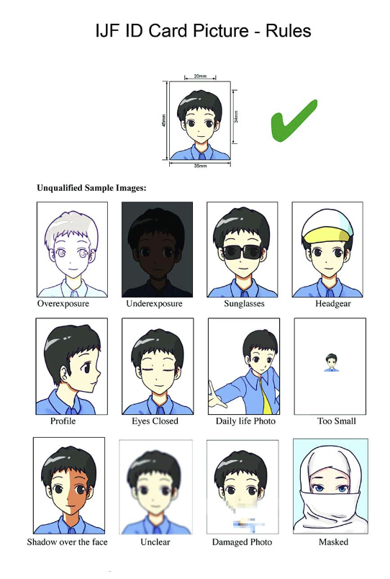 | YES

X NO

<<X NO

<< X NO

ANNEX 4 – ID card

The ID card must be valid and compliant with the rules below.

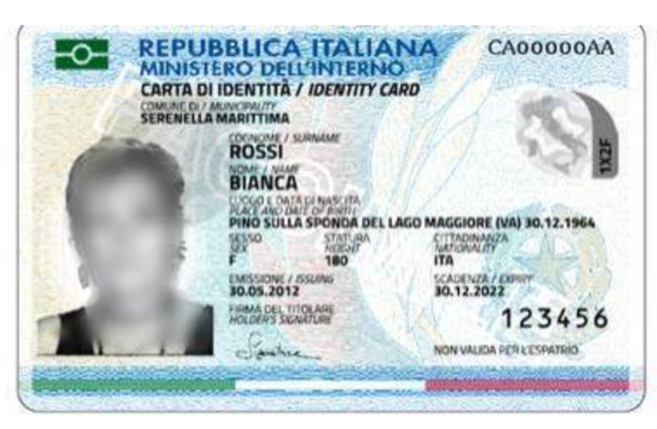

YES

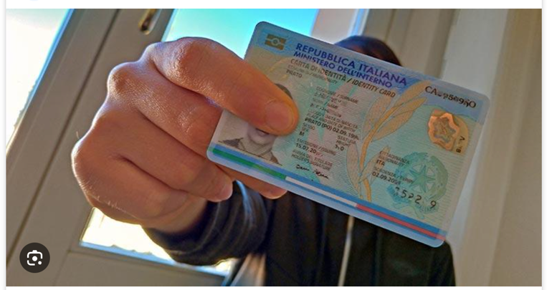 | << X NO

The Passport / Passports ID must be valid and compliant with the rules below.

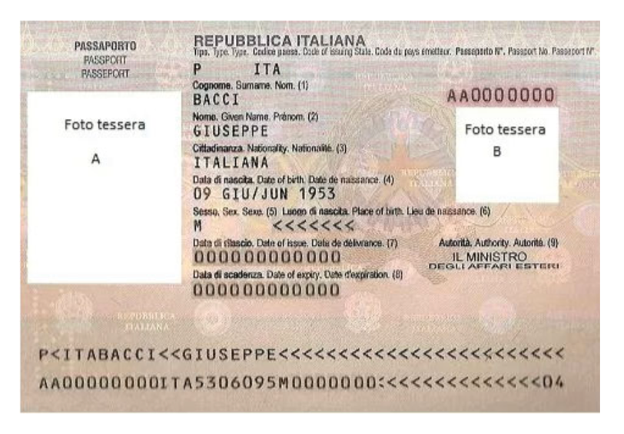 | YES

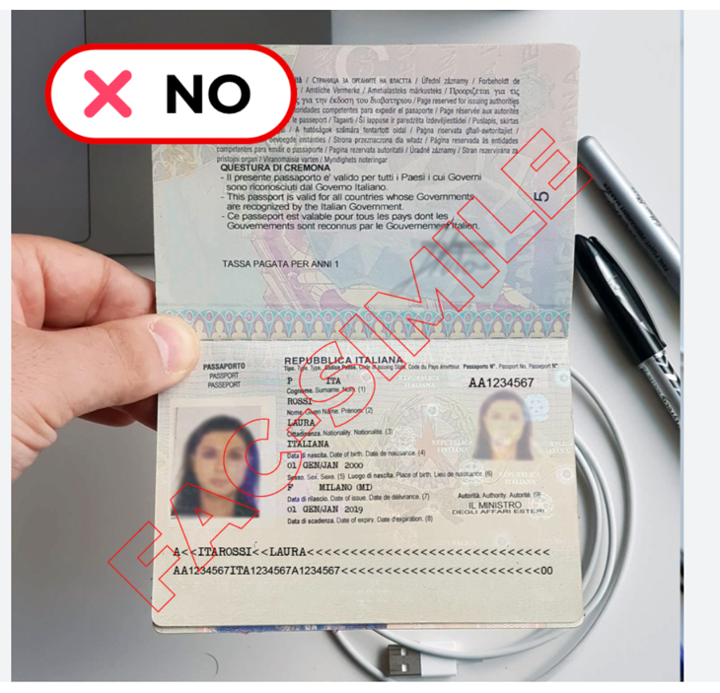

<< X NO

ANNEX 5 – Certification from the National Federation (Referee National Licence and Black belt)

The National Federation must report on its headed paper the following certification complete with signature of the Federation manager and stamp.
The certification must refer to a single candidate.

LETTERHEAD OF THE NATIONAL FEDERATION FOR WHICH
THE CANDIDATE IS REGISTERED IN THE IJF db
Candidate: (SURNAME and Name as written in the passport– for example ROSSI Michele Franco Junior)

Date of Birth: dd.mm.yyyy

Nationality: Italy

Exam: Continental License (31 May – 02 June 2024 – Graz, AUT)

With reference to the application for the IJF Continental License examination referred to above, this National Federation confirms that all the data reported by the candidate comply with what is recorded in our and in the IJF db.

In particular:

-Referee National License: (place and date - for example: Rome 2018)

-1st dan 2010 Rome
-2nd dan 2014 Rome
-3rd dan 2020 Rome
etc.

Date (dd.mm.yyyy) Signature and stamp of the Federation Secretariat

ANNEX 6 – IJF Academy licence copy

Example:



ANNEX 7 – Certification from payment

The undersigned (SURNAME Name) candidate for the IJF Continental License exam in (place) on (date) declare that I’m not able to make the relevant bank transfer for the following reasons: ________________________________________________________________
and asks to be able to make the payment on site, aware that I will not be able proceed with the exam unless I have paid the exam fee first.

Date, (dd.mm.yyyy) __________________

Signature __________________

