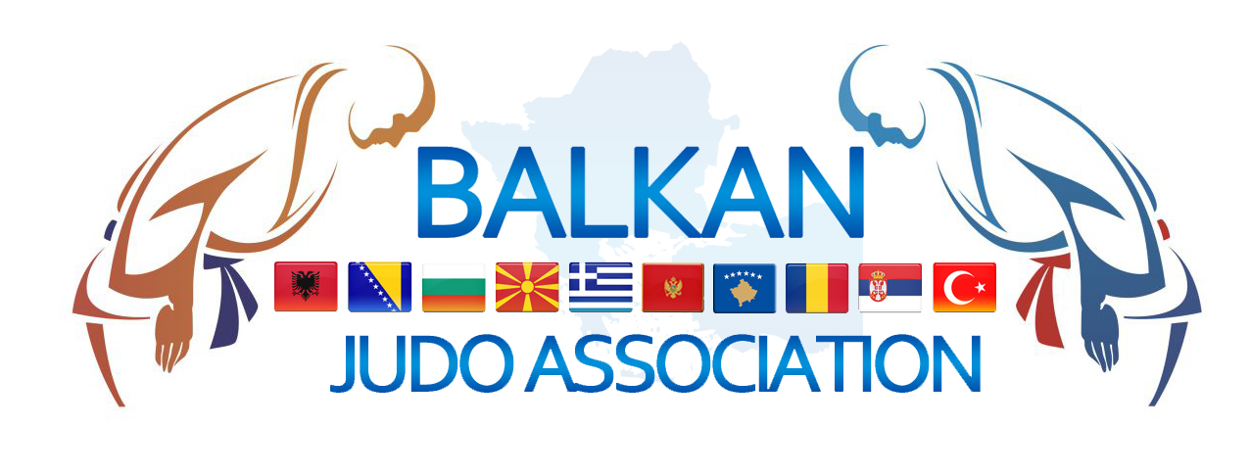
BALKAN JUDO ASSOCIATION
Tekırdağ , 04 / 10 /2022

To: Albanian Judo Federation, Bulgarian Judo Federation, Bosnia and Herzegovina Judo Federation, Hellenic Judo Federation, Moldova Judo Federation, Montenegro Judo Federation, North Macedonia Judo Federation, Romania Judo Federation, Serbia Judo Federation, Kosovo Judo Federation, Turkish Judo Federation
Guest: Cyprus Judo Federation
From: Deniz ŞİLLİ - General Secretary of Balkan Judo Association.

I N V I T A T I O N

Dear balkan members,

Balkan Judo Association has the pleasure to invite your judo federation to participate in Balkan Judo Championship for Individual Veterans - 2022 edition.
Below is the program for balkan judo competition.

BALKAN JUDO CHAMPIONSHIP for VETERANS ( UP 30 )
19 , 20 November , 2022 Tirana , ALBANIA

Organizer
ALBANIA JUDO FEDERATION
Address : Rr.”Grigor Heba 100” Parku Olimpik Tirana / ALBANIA
Telephone: +355 69 209 5469
E-mail : albjudofederation@hotmail.com
Contact persons: Dashnor Xhixho +355 69 410 2074
E-mail: dashnorxhixho3@gmail.com

Competition

The tournament will take place in Sports Hall ”Asllan Rusi’’
Adress: 8RM2+9J7, Rruga Ali Kolonja, Tirana, Shqipëri

Accreditation
Accreditation will be held at Terminal Hotel 14:00h – 18:00h
Address: Autostrada Tirane-Durres Km. 0, perball Spitalit Hygeia, Tiranë 1000

Official Weigh-in will take place at Terminal Hotel – for the veterans UP 30 Years and overs old
Friday
November 18 , 2022

M1-M2-M3-M4-M5-M6-M7-M8-M9
F1-F2-F3-F4-F5-F6-F7-F8-F9
Men - 60, - 66, - 73, -81, - 90, 100, +100 Kg;
Women - 48, - 52, - 57, -63, -70, -78, +78 Kg ;

Unofficial Weigh-in Veterans (UP 30) 16:00h-18:00h
Official Weigh-in Veterans ( UP 30 ) 18:00h-19:00h
Draw will take place in Terminal Hotel 19:00h
Referees meeting will take place in Terminal Hotel 20:00h

Saturday
November 19 , 2022

Veterans UP 30 Years and overs old
Category : F1-F2-F3-F4-F5-F6-F7-F8-F9 / M1-M2
Men - 60, - 66, - 73, -81, - 90, 100, +100 Kg ;
Women - 48, - 52, - 57, -63, -70, -78, +78 Kg ;
Preliminaries/Repechage: 10:00h
Opening Ceremony: 16:00h
Final block (medal contests): 16:30h

Official Weigh-in Veterans (Women and Men ) in Sport Hall 16:00h -17:00h

Lunch will be in sports hall: 13:00h – 15:00h

Veterans UP 30 Years or overs old
Sunday

November 20 , 2022

Category : M3-M4-M5-M6-M7-M8-M9
Men - 60, - 66, - 73, -81, - 90, 100, +100 Kg ;

Preliminaries/Repechage: 10:00h
Final block (medal contests): immediate after repechage
Lunch in sports hall: 12:00h – 13:00h

Athletes are not allowed to weigh-in naked. Boys must wear at least underwear and girls at least underwear and a T-Shirt. Additional 100g will be allowed for their weight category limits.

Accommodation will be at Terminal Hotel
Accommodation
The price is 55 euro for each person/day/full board
Accomodation starting with dinner – 18.11.2022
Only the athletes in the Veterans category will pay more than 30 euros.

Each member country may enter maximum two competitors in each weight category. Please note, that white and blue judogies are mandatory
Entries
The number of persons until October 24, 2022 and nominal entry form until November 07, 2022 to the organizing committee of Albania Judo Federation. www.judobalkan.org/logın (sportsman list will be entered )

Each federation must assume all responsibility for accidents and health insurance/person as well as civil liabilities for their competitors and officials during their stay in Albania.
Insurance

Referees
The balkan countries member may send at this tournament 3 - 5 judo referees.
If the country brings the referees to the EJU or IJF will receive 50 euro per day.
Total 100 euro to be paid. 1 referee will be paid for each country. No payment to other referees

Awards

1st, 2nd and 3rd place (2 places) will be awarded in each weight category.

Special Rules

M1/F1—M6/F6 3 Minutes Golden Score: No Limit
M7/F7--- M9F9 2,5 Minutes Golden Score: 1 Minute

Covid-19 Rules

There is no obligation for covid-19 measures according to government regulatıons in Albania.

Deniz ŞİLLİ
General Secretary of Balkan Judo Association

Nominal entry form
Please return before 07th November 2022
Telephone: .............................................
E-mail: ..................................................

Team of:

Athletes – boys

Athletes – girls

Coaches

Referees

Other officials

Total of persons

Final entry form VETERANS Girls (UP 30)
Please return before 07th November , 2022
Telephone: ..........................................
E-mail: ...............................................

Team of:

Officials
 | Surname | First name | Function
1.
2.
3.
4.
5.
6.

Referees
 | Surname | First name | Licence
1.
2.
3.

Women List ;

Weight cat. | Age Category | Surname | First name | Date of birth
Final entry VETERANS Boys (UP30)
Please return before 07th November, 2022
Telephone: .....................................................
E-mail: ............................................................

Team of:

Officials
 | Surname | First name | Function
1.
2.
3.
4.
5.
6.

Referees
 | Surname | First name | Licence
1.
2.
3.

Men List ;

Weight cat. | Age Category | Surname | First name | Date of birth

Visa Application Form

Team of

Our delegation needs the invitation from the______ till the ______ of ____________________.

We will apply for visas at the _______________ Embassy in _____________________________.

(country, city)
Please fill in the table in BLOCK LETTERS. Please also attach a COPY OF PASSPORT.
Date of expiry
Date of issue
Pass No
Nationality
Place of Birth
Date of Birth
Position
First Name
Surname

